Software Engineering and Project Management
Module – 5
Software Quality

1 Define Software Quality and explain the Importance of Software Quality
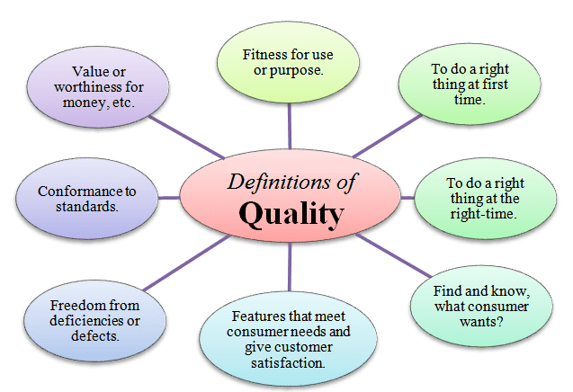
Software Quality: a system has functional, quality and resource requirements. Functional requirements define what the system is to do, the resource requirements specify allowable costs and the quality requirements state how well this system is to operate.

Importance of Software Quality:
We would expect quality to be a concern of all producers of goods and services. However, the special characteristics of software create special demands.

● Increasing criticality of software The final customer or user is naturally anxious about the general quality of software, especially its reliability. This is increasingly so as organizations rely more on their computer systems and software is used in more safety-critical applications, for example to control aircraft.

● The intangibility of software can make it difficult to know that a project task was completed satisfactorily. Task outcomes can be made tangible by demanding that the developer produce ‘deliverables’ that can be examined for quality.

● Accumulating errors during software development As computer system development comprises steps where the output from one step is the input to the next, the errors in the later deliverables will be added to those in the earlier steps, leading to an accumulating detrimental effect. In general, the later in a project that an error is found the more expensive it will be to fix.

2 Explain ISO 9126 six major external software quality characteristics:
● Functionality, which covers the functions that a software product provides to satisfy user needs;
● Reliability, which relates to the capability of the software to maintain its level of performance;
● Usability, which relates to the effort needed to use the software;
● Efficiency, which relates to the physical resources used when the software is executed;
● Maintainability, which relates to the effort needed to the make changes to the software;
● Portability, which relates to the ability of the software to be transferred to a different environment.

Functionality Suitability
- Accuracy
- Interoperability
- Functionality compliance
- Security
Reliability Maturity
- Fault tolerance
- Recoverability
- Reliability compliance
Usability
- Understandability
- Learnability
- Operability
- Attractiveness
- Usability compliance
Efficiency
- Time behaviour
- Resource utilization
- Effi ciency compliance
Maintainability
- Analysability
- Changeability
- Stability
- Testability
- Maintainability compliance
Portability
- Adaptability
- Installability
- Coexistence
- Replaceability
- Portability compliance
‘
3 Explain Product and Process Metrics
Product metrics help measure the characteristics of a product being developed. A few examples of product metrics and the specific product characteristics that they measure are the following: the LOC and function point metrics are used to measure size, the PM (person-month) metric is used to measure the effort required to develop a product

Process metrics help measure how a development process is performing. Examples of process metrics are review effectiveness, average number of defects found per hour of inspection, average defect correction time, productivity, average number of failures detected during testing per LOC, and the number of latent defects per line of code in the developed product.

Errors should therefore be eradicated by careful examination of the deliverables of each step before they are passed on. One way of doing this is by having the following process requirements for each step.

- Entry requirements, which have to be in place before an activity can start.
- Implementation requirements, which define how the process is to be conducted.
- Exit requirements, which have to be fulfilled before an activity is deemed to have been completed.
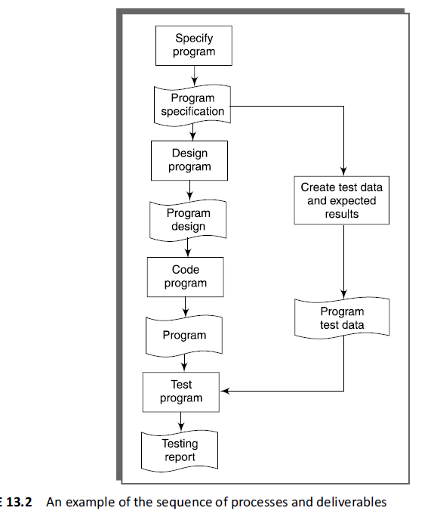

5 List the different Quality Management Systems and explain the principals of Quality Management Systems.
- SEI capability maturity model (CMM)
- CMMI (Capability Maturity Model Integration)
- ISO 15504 Process assessment
- Six Sigma
Principals of Quality Management Systems.
1. Determining the needs and expectations of the customer;
2. Establishing a quality policy, that is, a framework which allows the organization’s objectives in relation to quality to be defined;
3. Design of the processes which will create the products (or deliver the services) which will have the
qualities implied in the organization’s quality objectives;
4. Allocation of the responsibilities for meeting these requirements for each element of each process;
5. Ensuring that resources are available to execute these processes properly;
6. Design of methods for measuring the effectiveness and efficiency of each process in contributing to the organization’s quality objectives;
7. Gathering of measurements;
8. Identification of any discrepancies between the actual measurements and the target values;
9. Analysis and elimination of the causes of discrepancies.

6 Explain SEI capability maturity model (CMM)
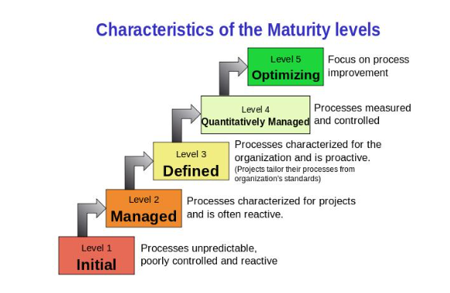
Level 1: Initial A software development organization at this level is characterized by haphazard activities by the members of project teams. The chaotic activities are primarily brought about by the lack of any definition of the development and management processes. Each developer feels free to follow any process that he or she may like.

Level 2: Repeatable Organizations at this level usually practice some basic project management practices such as planning and tracking cost and schedule. Further, these organizations make use of configuration management tools to keep the deliverable items under configuration control. As level 1 organizations, level2 organizations are characterized by any documented process. However, the developers usually have a rough understanding of the process being followed in the organization. As a result, such an organization can usually repeat its success on one project on other similar projects.

Level 3: Defined At this level, the processes for both management and development activities are defined and documented. There is a common organization-wide understanding of activities, roles, and responsibilities. At this level, the organization builds up the capabilities of its employees through periodic training programs

Level 4: Managed Organizations at this level focus on effectively managing development tasks by collecting appropriate process and product metrics. Quantitative quality goals are set for the products and processes. At the time of project completion, it is checked whether the quantitative quality goals for these have been met.

Level 5: Optimizing Organizations operating at this level not only collect process and product metrics, but analyse them to identify scopes for improving and optimizing the various development and management activities. In other words, these organizations strive for continuous process improvement.

7 Differentiate Verification versus validation
Aspect | Verification | Validation
Definition | Static process of checking documents, design, code, and program to see if software is built according to requirements. | Dynamic process of testing and validating the actual product to meet the exact needs of the customer.
Type of Testing | Static (does not involve code execution). | Dynamic (involves code execution).
Methods | Reviews, walkthroughs, inspections, desk-checking. | Black Box Testing, White Box Testing, Non-functional testing.
Focus | Conformity to specifications. | Meeting customer requirements and expectations.
Bug Detection | Finds bugs early in development. | Finds bugs not caught by verification.
Target | Application and software architecture, specification, design, database. | Actual software product.
Execution Team | Quality assurance team. | Testing team
Sequence in Development | Performed before validation. | Follows verification.
Nature of Checks | Checking of documents/files by humans. | Execution of program by computer.
Purpose | Ensures correct implementation of functions. | Ensures software is traceable to customer requirements.
Key Concern | Aligning with customer and business requirements at each stage. | Functioning across different conditions and environments.
Defect Detection Rate | Finds about 50-60% of defects. | Finds about 20-30% of defects.
Dependence | Based on reviewer's opinion, may vary. | Based on factual testing, often stable.
Emphasis | Process, standards, guidelines. | Product itself.
Execution Requirements | Does not require devices, platforms, browsers, OS. | Best executed using real browsers, devices, OS.

